1. Does the subject have admission restrictions?
Even if you meet the general requirements and have chosen your desired subject, you will frequently not be able to enroll directly. For many degree programs in Germany, there are more prospective students than study places, so applicants first have to take part in an admission procedure.
-> There are two types of admission restrictions: those determined locally, which means they only apply at certain higher education institutions, and those that apply throughout Germany. You can usually enroll directly if your intended degree program has no admission restrictions.

2. Do the admission restrictions apply locally or throughout Germany?
Germany-wide admission restrictions: Degree programs such as medicine, pharmacy, veterinary medicine, and dentistry are so popular that admission restrictions apply at all German higher education institutions. They have what is known as a numerus clausus (NC). Study places are awarded by the Stiftung für Hochschulzulassung (Foundation for University Admissions) for applicants from Germany and other EU member states as well as applicants from Liechtenstein, Iceland, and Norway (available only in German).
->Local admission restrictions: Some degree programs only have admission restrictions at particular higher education institutions. These are frequently described as NC degree programs. In addition to an overall average grade, higher education institutions can specify further criteria they will consider when selecting applicants, such as a letter of motivation, tests, or selection interviews. These criteria differ between higher education institutions and between study programs.

TIP: Contact the International Office of your higher education institution directly for information before applying. You can find the academic counseling offices on the Higher Education Compass website.

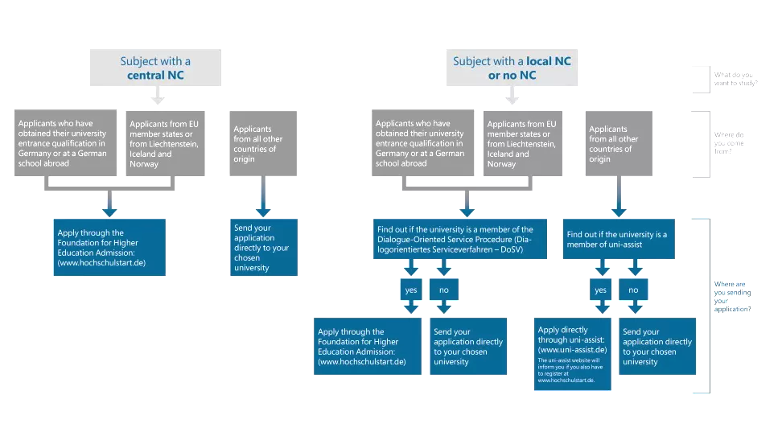
3. Where do I apply?

4. Which documents will I need?
The International Offices of the higher education institutions can help answer this question. They will tell you about the application process and which documents have to be submitted. The application form is available from your chosen higher education institution, from uni-assist, or the Stiftung für Hochschulzulassung (only in German).

As a general rule, you will need the following documents:

- An officially certified copy of your higher education entrance qualification
- An overview of your subjects and grades (with official translation)
- Certified copies of your previous higher education certificates, if applicable
- A passport photograph
- A photocopy of your passport (name and photograph)
- Certified copies of language certificates
- Please note: Only officially certified copies and translations are accepted for the application process. Official certifications can be issued for example by the German embassy in your home country. Some higher education institutions also accept documents in English and French.

Document certification and application processing fees vary. For uni-assist, it’s 75 EUR for the first study choice and 30 EUR for each additional course in the same semester.

The process by which the application form for a higher education institution (for example, the institution that appears in the chart) is submitted can take place in various ways, for example, with a form that can be filled out on the Internet and then printed out, or with an online form. Please enquire directly at the international office of the higher education institution to which you are applying.

5. When does the application have to be completed?

Winter Semester (September/October)
- Application period: Early May to July 15
- Acceptance letters: Sent in August/September
- Rejections: Typically sent later

Summer Semester (March/April)
- Application period: Early December to January 15
- Acceptance letters: Sent in February/March
- Rejections: Typically sent later.

Note: Private universities may have different deadlines.

FIVE TIPS FOR DEALING WITH THE NUMEROUS CLAUSES (NC)
- Write multiple applications: Submitting more applications to different higher education institutions increases your chances of success.
- Choose less popular locations: Most students want to study in major cities or traditional university towns. We recommend applying to higher education institutions at less popular locations.
- Gain additional points: The grades on your higher education entrance qualification are not always the only criterion for awarding a study place. Sometimes certain grades are weighted more heavily or there are aptitude tests.
- Try your luck: Higher education institutions award some study places by lottery because the originally selected applicants turn down their offered place. It is important to know the dates and conditions of this lottery.
- Start in the summer semester: Around one-quarter of all Bachelor's programs can also be started in the summer semester.

